Assignment – 1

Solution:

Tree:

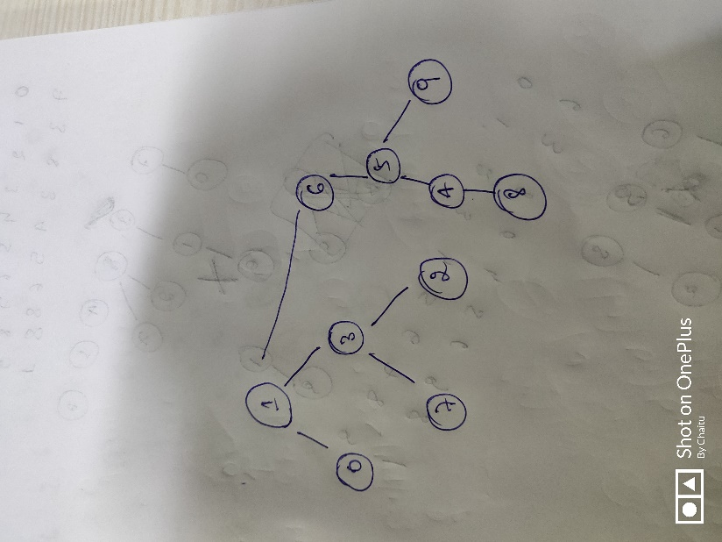

This tree is not a result of Weighted Quick Union because when we are connecting 5 to 6, size of 5 tree is 2 and size of 6 tree is 1. So 6 should get attached to 5.